D197 - Version Control

Step A Screenshots
Below is a screenshot of the current repository graph in Gitlab after completing the steps in A:
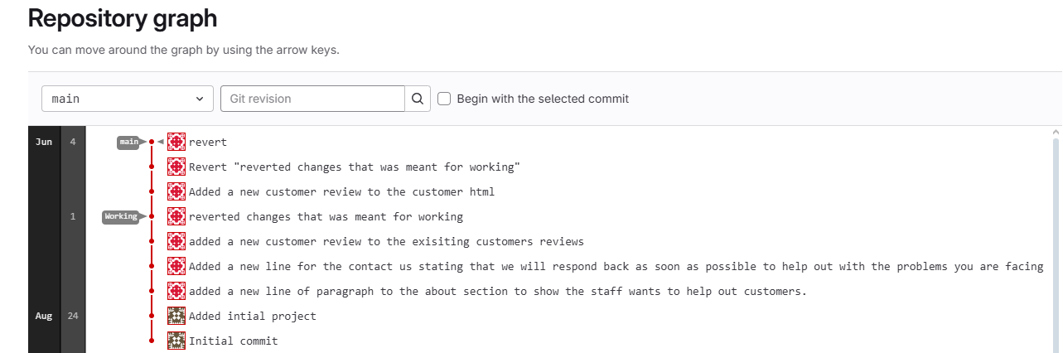
Step B Screenshot
Below is a screenshot of the command line action (be sure to have your repository name visible in the
command prompt) after completing the steps in B:
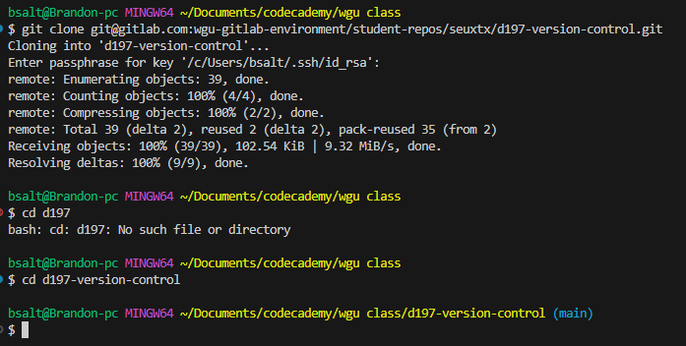

Step C Screenshots
Below is a screenshot for each git command for each change made to the HTML files after completing
the steps in C:
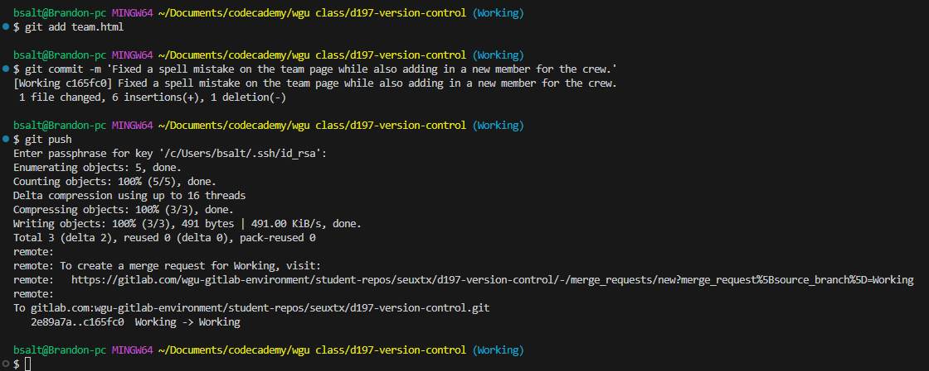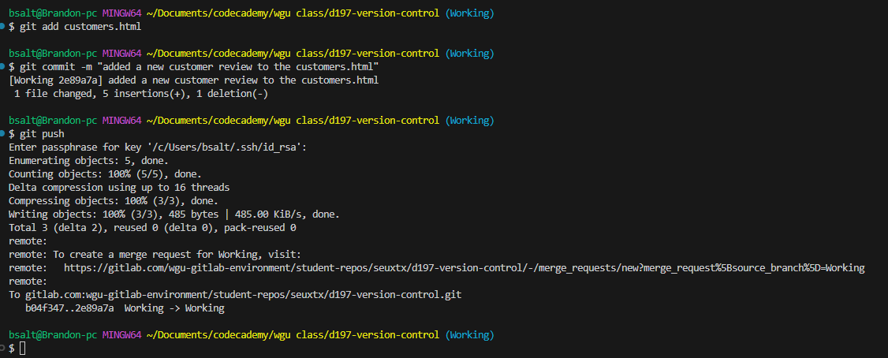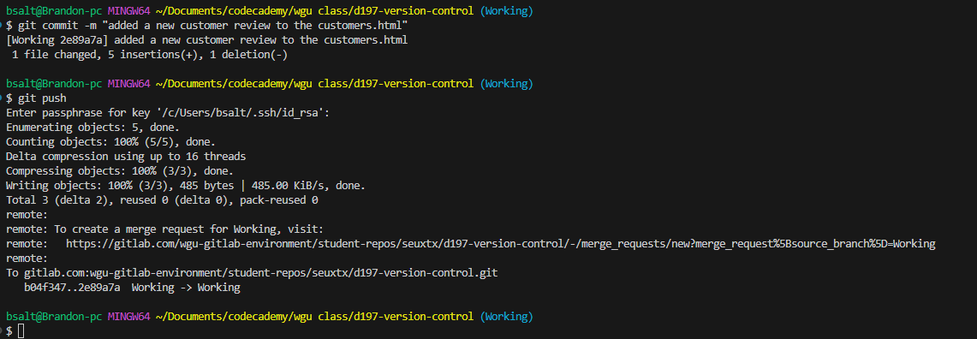

Step D Screenshots
Below is a screenshot of the command line action after completing the steps in D:
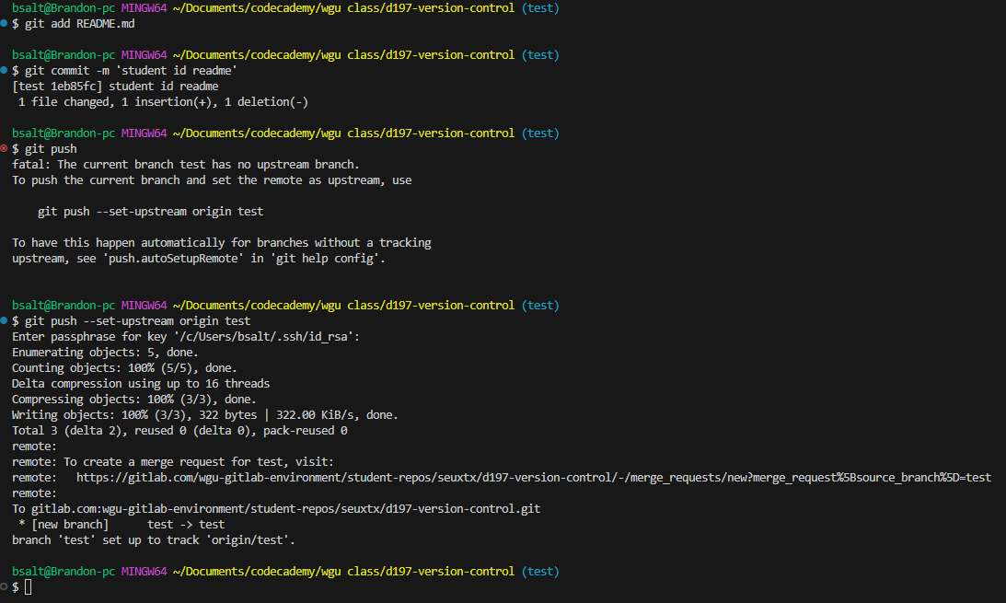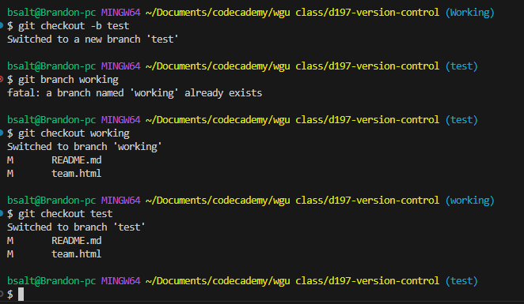

Below is a screenshot of the current repository graph in Gitlab after completing the steps in D
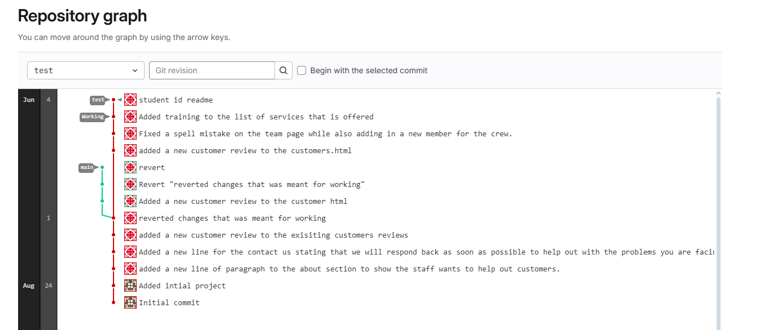

Step E Two Screenshots
Below is a screenshot that demonstrates the conflict of a merge command line action (be sure to have your repository name visible in the command prompt) after completing the steps in E: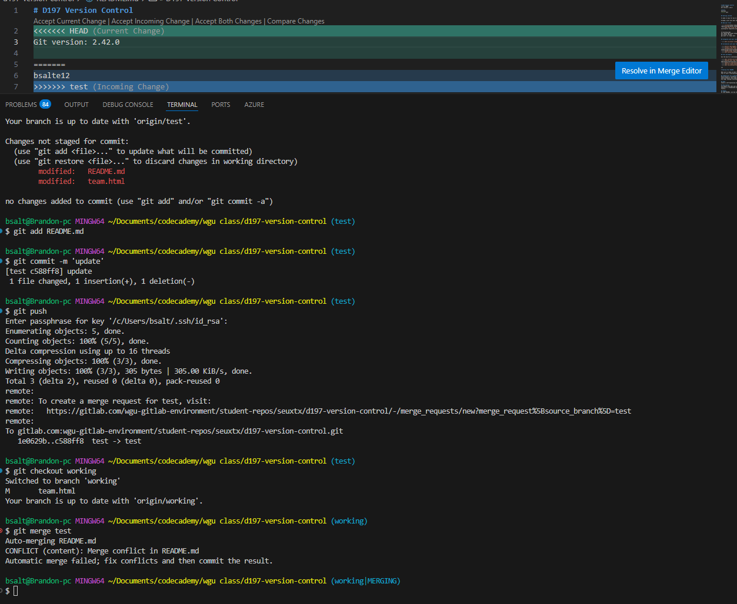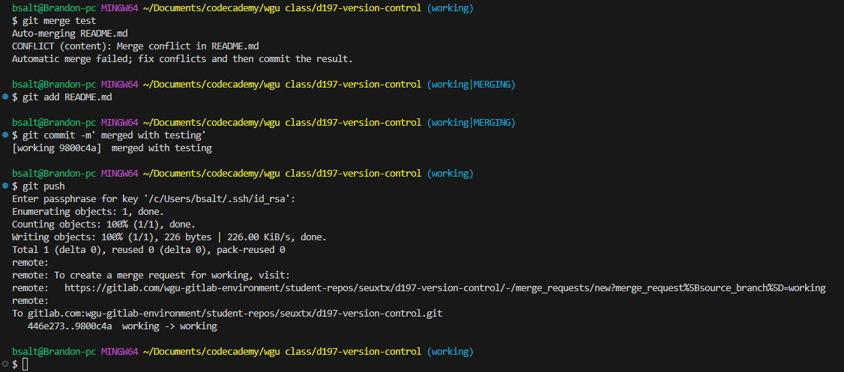
Below is a screenshot of the current repository graph in Gitlab after completing the steps in E:
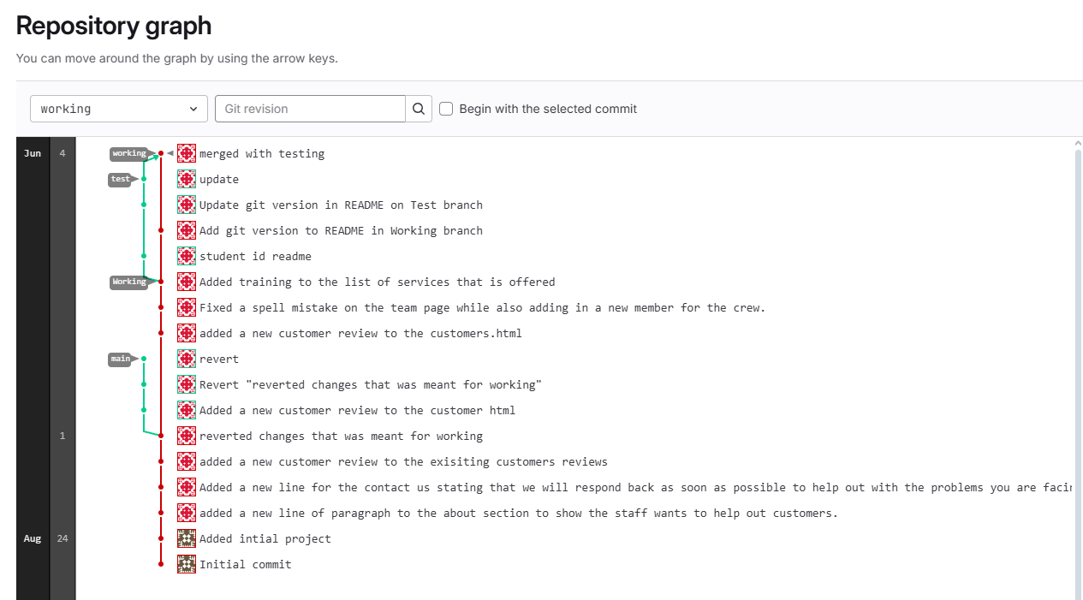

Step F Screenshots
Below is a screenshot of the command line action after completing the steps in F:
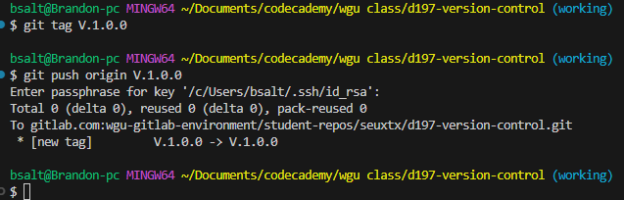

Below is a screenshot of the current repository graph in Gitlab after completing the steps in F: